**Sorting Algorithms Analysis**

Analysis of Algorithms Assignment



**Submitted to:** Sir Atif

**Submitted by:** Hamza Farooq Reg. 2016-CS-122

Department of Computer Science and Engineering

University of Engineering and Technology Lahore

Contents

Sorting Algorithms 2

Bubble Sort 2

Bubble Sort Time Complexity 2

Insertion Sort 3

Insertion Sort Time Complexity 3

Selection Sort 4

Selection Sort Time Complexity 4

Merge Sort 5

Merge Sort Time Complexity 6

Quick Sort 6

Quick Sort Time Complexity 6

Radix Sort 7

. 8

Radix Sort Time Complexity 8

Bucket Sort 9

Bucket Sort Time Complexity 9

Heap Sort 10

Heap Sort Time Complexity 10

## Sorting Algorithms

# Bubble Sort

# 

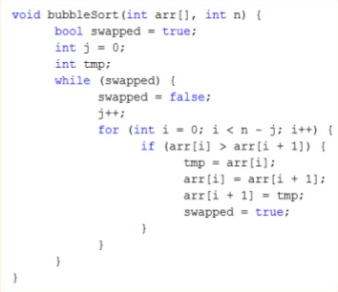

# Bubble Sort Time Complexity

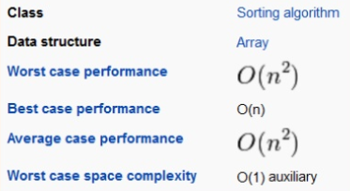

# Insertion Sort

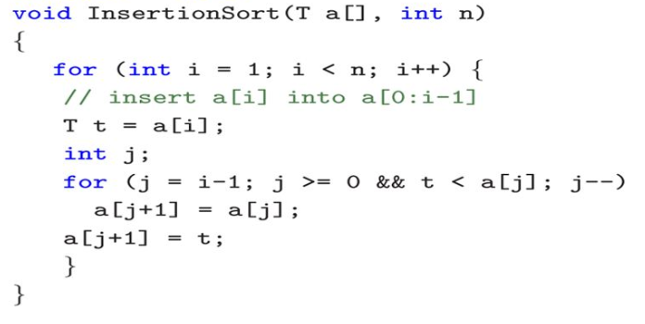

# Insertion Sort Time Complexity

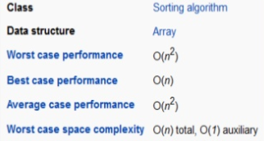

# 

# Selection Sort

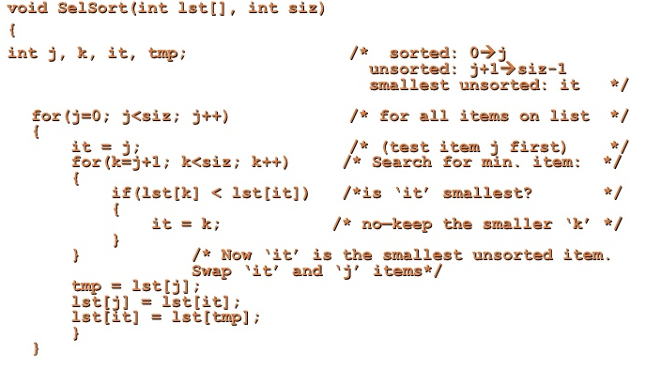

# Selection Sort Time Complexity

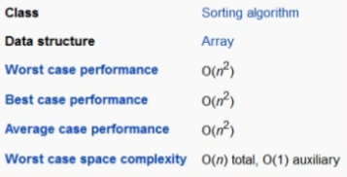

# Merge Sort

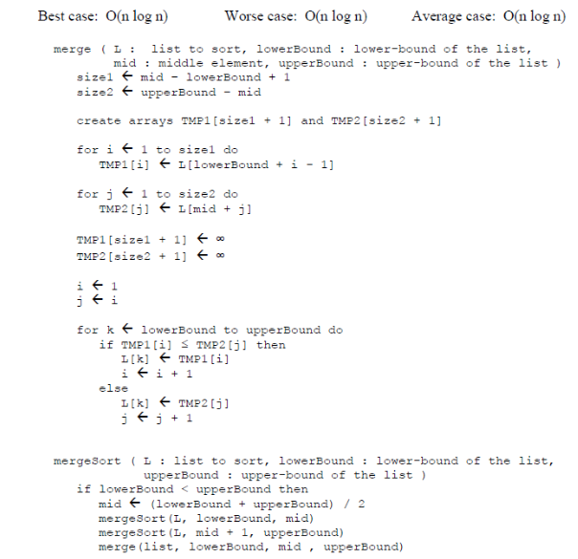

# Merge Sort Time Complexity



# Quick Sort

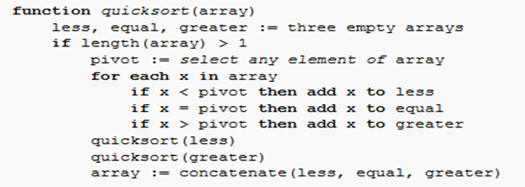

# Quick Sort Time Complexity

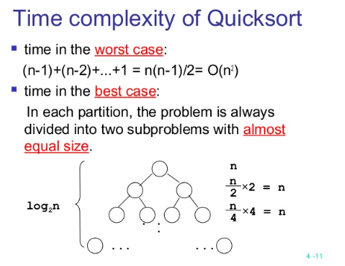

# Radix Sort

# .

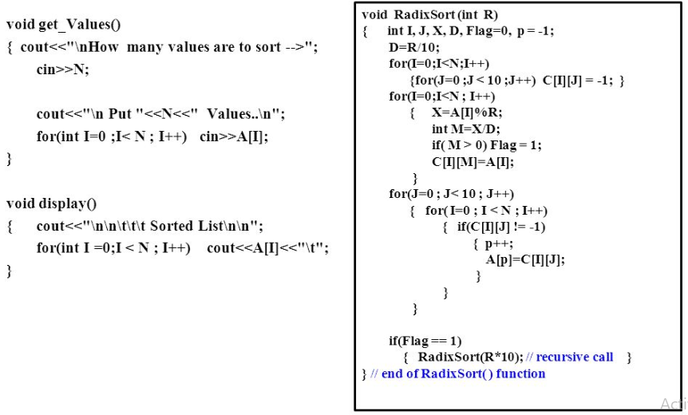

# Radix Sort Time Complexity

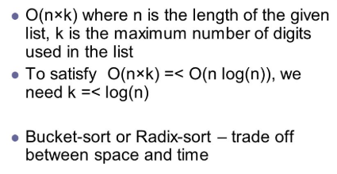

# 

# Bucket Sort

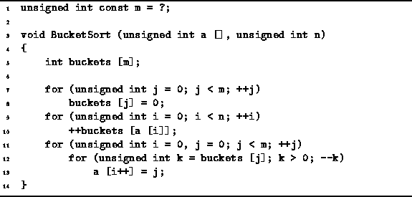

# Bucket Sort Time Complexity

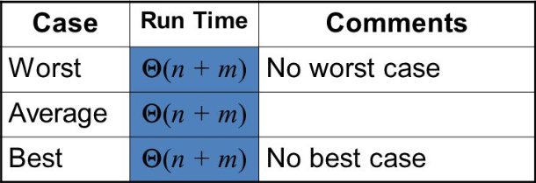

# 

# Heap Sort

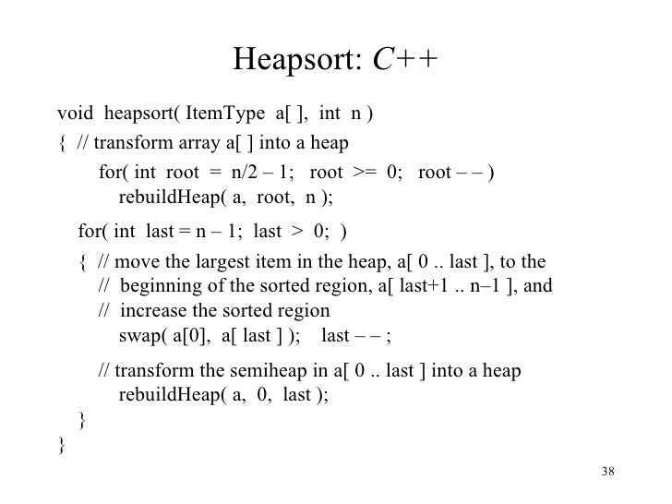

# Heap Sort Time Complexity

